**Download and Install Spring Tool Suite IDE on Windows**

1. What is Spring Tool Suite IDE?

Spring Tool Suite (STS) is an IDE based on Eclipse IDE - one of the most popular Java IDEs. You’re already familiar with Eclipse, you will find STS easy to use like Eclipse.

STS is free and open-source. It is developed by The Spring Team at VMWare which is the company that manages Spring platform, so it is best suited for developing Spring-based projects.

The latest version of STS is 4.15.1 (as of July 2022). Note that Spring Tool Suite 4 is officially named as Spring Tools 4 for Eclipse.

2. Download Spring Tool Suite for Windows

Head over to the home page of Spring Tool Suite at https://spring.io/tools, and click the download button for Windows X86_64:

It will download a self-extracting JAR file spring-tools-suite-xxx.jar (around 578 MB), which means you need to run a java command to install it.

3. Install Spring Tool Suite on Windows

Copy or move the downloaded JAR file to a desired directory. Open a new command prompt window. The use the cd command to change the current directory to that directory:

cd <sts_install_directory>

And type the following command:

java -jar spring-tool-suite-xxx.jar

then you will see a small window pops up as shown below:

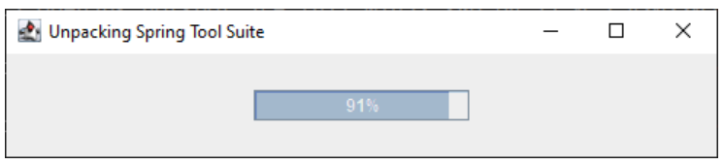

And in the command prompt you will see lots of process messages like this:

When the installation complete, the popup window disappears and the java command terminates. You will see the files extracted to a directory named sts-4.15.1.RELEASE, in which you see the SpringToolSuite4.exe program that is the launcher of Spring Tool Suite IDE:

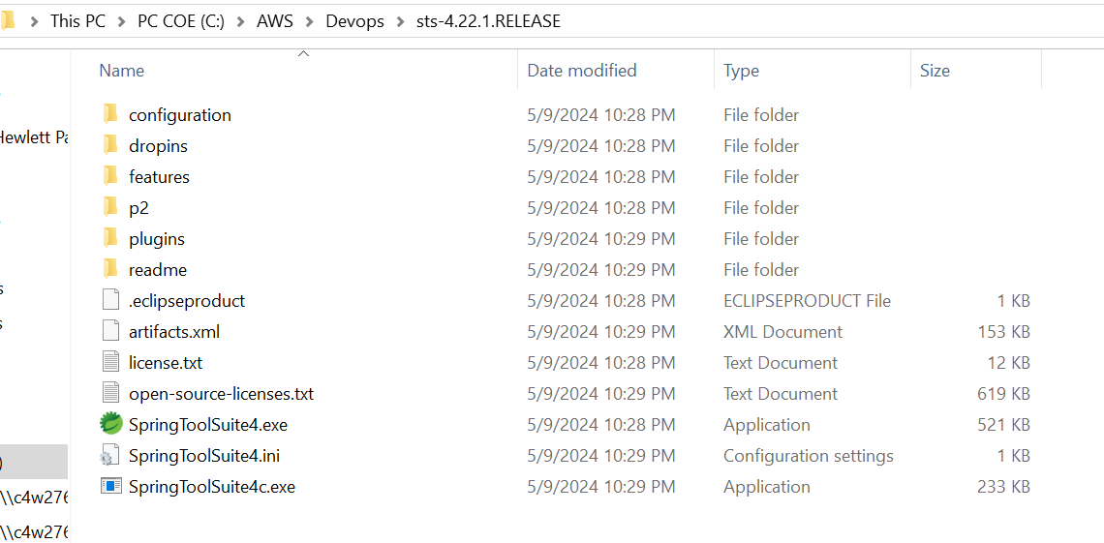

Now, double click the SpringToolSuite4.exe file to launch Spring Tool Suite IDE. You should see the following splash screen:



Then it asks you to select a directory as workspace:

You can choose the default one or any directory you wish, then click Launch. The main window of STS IDE appears as shown below:

Done! You have successfully installed Spring Tool Suite IDE on Windows operating system.